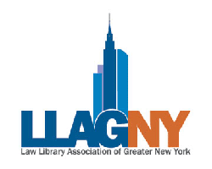

LLAGNY’s 76th year has begun!
Join us in welcoming our new members by attending the

New Member Welcome & Fall Soiree Reception
Tuesday, October 14th, 6:00-8:30 p.m.

Club 101
101 Park Avenue @ 41st St.
4, 5, 6 or 7 to Grand Central
or 1,2,3, N, Q, R to Times Square and take shuttle to Grand Central

LLAGNY will announce and introduce our valued
Sponsorship Support Partners for 2014-2015

Special Committee Address given by
Daniel Mitrano, Editor & Taryn Rucinski, Managing Editor - Law Lines
&
Mary Matuszak & Jillian Eum, Co-Chairs Volunteer Committee
RSVP through LLAGNY.org by Friday, October 10th
http://tinyurl.com/2014fallsoiree

